High Level Design & Low Level Design

The purpose of this document is to provide with a template for documenting both HLD & LLD.

**Document Control :**

|  |  |  |  |  |  |  |  |  |
| --- | --- | --- | --- | --- | --- | --- | --- | --- |
| **Project Revision History** | | | | | | | | |
|  |  |  | |  |  |  |  |  |
| **Date** | **Version** | **Author** | **Brief Description of Changes** | | | | **Approver Signature** | |
| 2/11/2022 | 0.1 | whole team | SRS briefing | | | |  | |
| 4/11/2022 | 0.5 | whole team | Design | | | |  | |
| 8/11/2022 | 1 | whole team | Coding and UT-IT test cases | | | |  | |

1. Introduction 3

1.1. Intended Audience 3

1.2. Acronyms/Abbreviations 3

1.3. Project Purpose 3

1.4. Key Project Objectives 3

1.5. Project Scope and Limitation 3

1.5.1. In Scope 3

1.5.2. Out of scope 3

1.6. Functional Overview 3

1.7. Assumptions, Dependencies & Constraints 3

1.8. Risks 3

2. Design Overview 3

2.1. Design Objectives 3

2.1.1. Recommended Architecture 3

2.2. Architectural Strategies 3

2.2.1. Design Alternative 3

2.2.2. Reuse of Existing Common Services/Utilities 3

2.2.3. Creation of New Common Services/Utilities 3

2.2.4. User Interface Paradigms 3

2.2.5. System Interface Paradigms 3

2.2.6. Error Detection / Exceptional Handling 3

2.2.7. Memory Management 3

2.2.8. Performance 3

2.2.9. Security 3

2.2.10. Concurrency and Synchronization 3

2.2.11. Housekeeping and Maintenance 3

3. System Architecture 3

3.1. System Architecture Diagram. (Not Necessary) 3

3.2. System Use-Cases 3

3.3. Subsystem Architecture 3

3.4. System Interfaces 3

3.4.1. Internal Interfaces 3

3.4.2. External Interfaces 3

4. Detailed System Design 3

4.1. Key Entities 3

4.2. Detailed-Level Database Design 3

4.2.1. Data Mapping Information 3

4.2.2. Data Conversion 3

4.3. Archival and retention requirements 3

4.4. Disaster and Failure Recovery 3

4.5. Business Process workflow 3

4.6. Business Process Modeling and Management (as applicable) 3

4.7. Business Logic 3

4.8. Variables 3

4.9. Activity / Class Diagrams (as applicable) 3

4.10. Data Migration 3

4.10.1. Architectural Representation 3

4.10.2. Architectural Goals and Constraints 3

4.10.3. Logical View 3

4.10.4. Architecturally Significant Design Packages 3

4.10.5. Data model 3

4.10.6. Deployment View 3

5. Environment Description 3

5.1. Time Zone Support 3

5.2. Language Support 3

5.3. User Desktop Requirements 3

5.4. Server-Side Requirements 3

5.4.1. Deployment Considerations 3

5.4.2. Application Server Disk Space 3

5.4.3. Database Server Disk Space 3

5.4.4. Integration Requirements 3

5.4.5. Jobs 3

5.4.6. Network 3

5.4.7. Others 3

5.5. Configuration 3

5.5.1. Operating System 3

5.5.2. Database 3

5.5.3. Network 3

5.5.4. Desktop 3

6. References 3

7. Appendix 3

# 

# Introduction

[The introduction of the **HLD LLD Document** should provide an overview of the Project. It should include the purpose, scope, definitions, acronyms, abbreviations, references and overview of the **HLD LLD Document**.]

## Intended Audience

[This section of the **HLD LLD Document** should provide the Names and Roles of the resources the **HLD LLD Document** is intended for and what is to be expected out of this document.]

|  |  |
| --- | --- |
| CPP |  |
| Val grind |  |

## Acronyms/Abbreviations

[This subsection should provide the definitions of all terms, acronyms, and abbreviations required to interpret properly the **HLD LLD Document**.  This information may be provided by reference to the project Glossary.]

|  |  |
| --- | --- |
| UT | Unit Test |
| IT | Integrated Test |
|  |  |
|  |  |

## Project Purpose

[This section of the **HLD LLD Document** defines the purpose of the Project.]

Exam Center Assignment purpose is to allocate exam center for candidate based on the exam he/she is appearing.

.

## Key Project Objectives

[This section of the **HLD LLD Document** defines the Key Project Objectives.]

To schedule without interference between exams by maintaining time management.

## Project Scope and Limitation

[This section of the **HLD LLD Document** defines the scope of the project and the Limitations in executing the project.]

Scheduling without interference and making all exams done for given candidates without leaving any candidates given in list of file. There will be some interference if candidate gets allocated two exam centers.

### In Scope

[This section of the **HLD LLD Document** defines what all is expected and in the scope of the project]

This Project allocates exam centers to candidates based on the candidate id, exam id

**1.5.2.**  **Out of scope**

[This section of the **HLD LLD Document** defines what is out of the scope of the project]

Required to involve techniques such as concurrency, inheritance to make the project done completely.

## Functional Overview

[This section of the **HLD LLD Document** Provides a general description of the software system including its functionality and matters related to the overall system function and its design Feel free to split this discussion up into subsections (and sub sections, etc ...).]

CPP ATL enables to code the job specifications ,FileIO operations helps to read file from Command line arguments and write schedule into different text files .Valgrind captures the data of memory leak.

## Assumptions, Dependencies & Constraints

[This section of the **HLD LLD Document** is for describing any assumptions, dependencies or constrains that are taken into consideration while preparing this document. These may concern such issues as:

Related software or hardware

Operating systems

End-user characteristics

Possible and/or probable changes in functionality]

Schedule for different exams is done by assuming the candidate info given in the candidate file is of correct format. Modified application will remove the exams that are not in correct format.

## Risks

[This section of the **HLD LLD Document** is for describing the risks that are taken into consideration while preparing this document. All the risks related to Software, Hardware, Operating System, Users, etc have to be documented here.]

All assumptions, functional overview and design parameters are documented without evaluation which are to be implemented without missing.

# Design Overview

In this section, a general description of the software system including its functionality and matters related to the overall system and its design has to be documented.]

## Design Objectives

[In this section, a general description of the system’s design objectives including matters related to the overall system and its design has to be documented.]

Design objectives include different parameters like exams given to candidate and scheduling corresponding exam centers and providing interference less design while assigning exam centers to candidates.

### Recommended Architecture

[In this section, a document the Recommended System Architecture]

UML architecture.

## Architectural Strategies

[Describe any design decisions and/or strategies that affect the overall organization of the system and its higher-level structures. These strategies should provide insight into the key abstractions and mechanisms used in the system architecture. Describe the reasoning employed for each decision and/or strategy (possibly referring to previously stated design goals and principles) and how any design goals or priorities were balanced or traded-off. ]

No architectural strategies have been employed.

### Design Alternative

[All the available alternatives have to be documented here along with the reasons for selection or rejection of the particular alternative.]

Designed sequence diagram and use case diagram as design paradigm but as an alternative selected class diagram to visualize more data that've used in application.

### Reuse of Existing Common Services/Utilities

[Document the details of all the available common services or Utilities that will be used by this system here.]

Design and development is done from scratch using existing sources star UML for design and VI for development.

### Creation of New Common Services/Utilities

[Document the details of all the new services or Utilities that have to be created as part of this system here.]

Used existing resources to develop the application specific services.

### User Interface Paradigms

[Document the User Interface Paradigms here.]

### System Interface Paradigms

[Document the System Interface Paradigms here.]

### Error Detection / Exceptional Handling

[A good system design ensures Error Detection and Exception handling procedures. Document all the details on how the Error detection has to be done in the system and how the Exceptions are thrown and handled in the system in this section.]

The files that are sent through command line argument are checked for exception and catches exception if it occurs and at the conditions where the source code may terminate gets checked for exceptions by placing that code in try block if any exceptions it cached by catch block.

### Memory Management

[Memory Management is a critical aspect of any system. A system designed keeping Memory Management in view uses very less Memory and frees up unused memory at frequent intervals. Document all the Memory Management policies, Critical issues related to Memory Management like Relocation, Protection, Sharing, Logical and Physical Organization etc. to be implemented in the system here. Focus on Design Decisions to Manage Memory.]

This application involves Dynamic memory allocation which allows us to use only required memory without reserving extra memory. Valgrind application used to check for memory leaks if any and rectified if any memory leaks occur.

### Performance

[Another critical aspect of any system is Performance. A system designed keeping Performance in view uses is fast and very responsive. Document all the System Performance requirements here. Focus on Design Decisions to manage Performance.]

System performance needs to be accurate while scheduling for each machine. Each machine schedule is to be done in different files as given without interference.

### Security

[Security has emerged as the most important aspect of any system. A system designed with good security principles ensures Integrity of the system and prevents from attacks and data leakage. Document all the Security Requirements and features implemented in the system including the use and management of integrity and access controls that apply to the system and its components. Also include any tools that will support security and privacy requirements.]

The source code is available only in read only mode for others who are accessing file and final executable file is only available for further modifications.

### Concurrency and Synchronization

[If the system needs to be in synch with another system, the details of the same have to be documented here.]

Application is designedd to work concurrently without interfering with the function of other part of code and also work simultaneously.

### Housekeeping and Maintenance

[All the details with respect to the Housekeeping and Maintenance of the system like clearing of logs, clearing up Memory details, Purging the Database of old records have to be documented here.]

Makefile is cleared first to remove the previous cache and text files are used to manage the database.

# System Architecture

[This section should provide a high-level overview of how the functionality and responsibilities of the system were partitioned and then assigned to subsystems or components. The main purpose here is to gain a general understanding of how and why the system was decomposed, and how the individual parts work together to provide the desired functionality.

At the top-most level, describe the major responsibilities that the software must undertake and the various roles that the system (or portions of the system) must play. Describe how the system was broken down into its components/subsystems (identifying each top-level component/subsystem and the roles/responsibilities assigned to it). Describe how the higher-level components collaborate with each other in order to achieve the required results.]

## System Architecture Diagram. (Not Necessary)

[If there are any diagrams, models, flowcharts, documented scenarios or use-cases of the system behavior and/or structure, they may be included here.]

## System Use-Cases

[If there are any documented scenarios or use-cases of the system behavior and/or structure, they may be included here]

We use use-case diagram to indicate the actors as candidate and application and use case as exam centers.

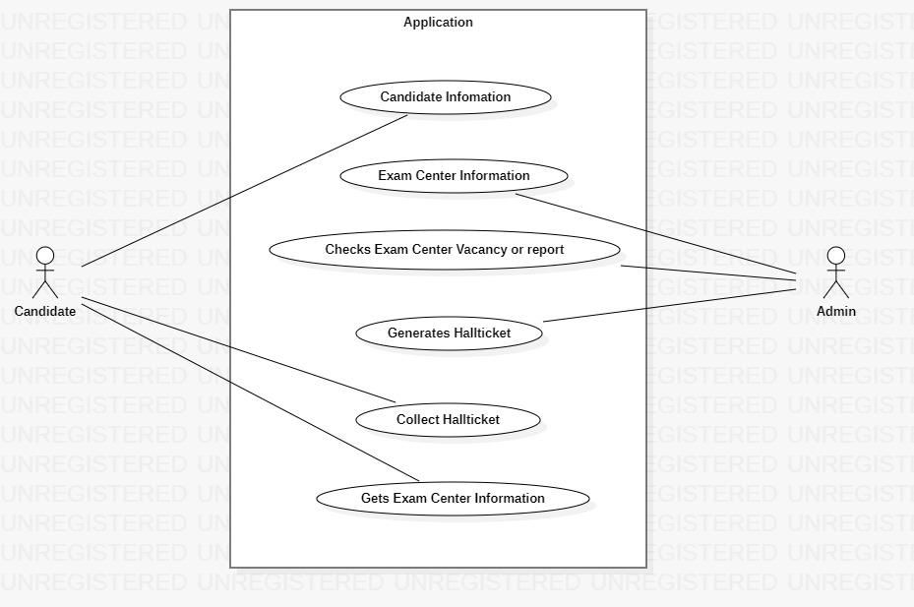

## Subsystem Architecture

[If a particular component is one which merits a more detailed discussion than what was presented in the System Architecture section, provide that more detailed discussion in a subsection of the System Architecture section. If necessary, describe how the component was further divided into subcomponents, and the relationships and interactions between the subcomponents.

If any subcomponents are also deemed to merit further discussion, then describe them in a separate subsection of this section. Proceed to go into as many levels/subsections of discussion as needed in order for the reader to gain a high-level understanding of the entire system or subsystem (but remember to leave the gory details for the Detailed System Design section).]

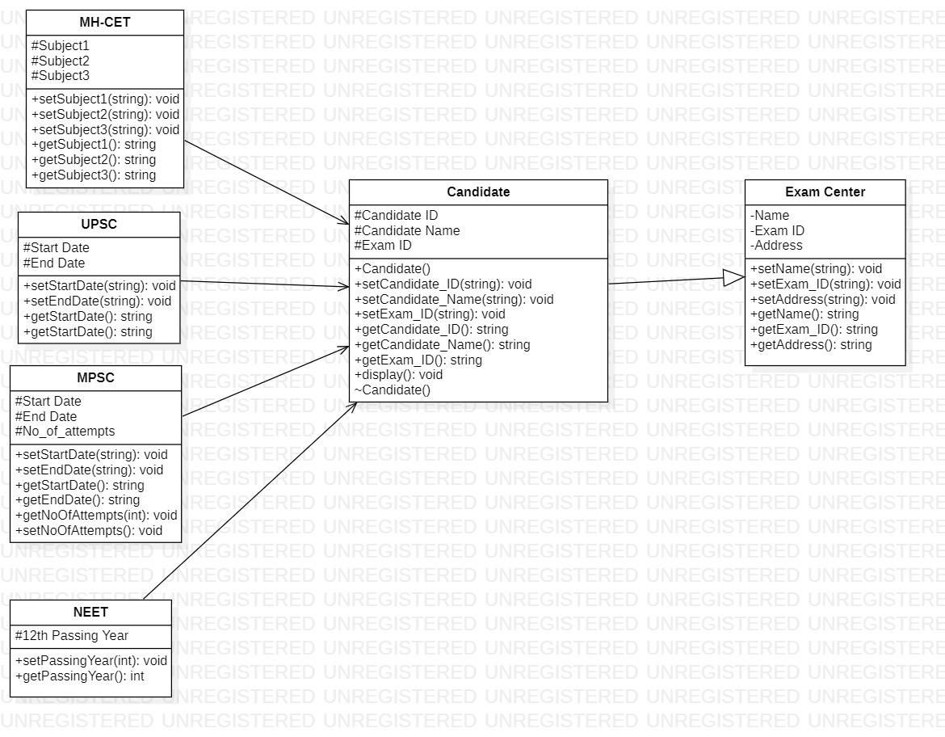

## System Interfaces

[A good design ensures that all the System’s Interfaces are well documented. List out the details of all the System Interfaces, interface Design along with diagrammatic representation if possible with details of flow, frequency etc.]

### Internal Interfaces

[Document all the details of Internal Interfaces the system interacts with along with the details of data flow and frequency.]

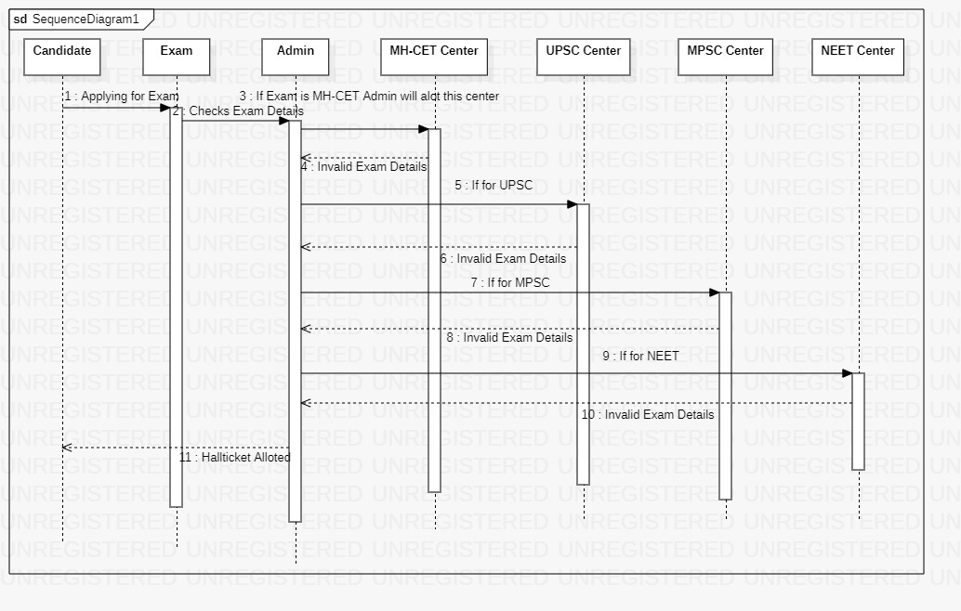

### External Interfaces

[Document all the details of External Interfaces the system interacts with along with the details of data flow and frequency.]

# Detailed System Design

[Most components described in the System Architecture section will require a more detailed discussion. Other lower-level components and subcomponents may need to be described as well. Each subsection of this section will refer to or contain a detailed description of a system software component. The discussion provided should cover the following software component attributes in complete detail.]

## Key Entities

[Provide a Comprehensive list of the Key Entities associated with the System in this section.]

We use key entities as valgrind and gdb.

## Detailed-Level Database Design

[The detailed database design information can be included here. Describe in detail the design of the database; all database related files associated with the system, and any non-DBMS files pertinent to the database design. Include discussions about or references to the following:

• Logical Data Model (LDM) and LDM Entity Relationship Diagram (ERD).

• Physical Data Model (PDM) and PDM ERD.

• A comprehensive Data Dictionary showing data stores, data element name, type, length, source, constraints, validation rules, maintenance (create, read, update, delete (CRUD) capability), audit and data masking requirements, expected data volumes, life expectancy of the data, information life-cycle management strategy or at least an archiving strategy, outputs, aliases, and description.

• Indexes that will be required for the data objects.

• Planned implementation factors (e.g., distribution and synchronization) that impact the design.]

### Data Mapping Information

[The detailed data mapping information has to be documented here. Describe in detail the requirements of data mapping, Data Models to be mapped, Integration details etc. including

[Data transformation](http://en.wikipedia.org/wiki/Data_transformation) or [data mediation](http://en.wikipedia.org/wiki/Data_mediation) between a data source and a destination

Identification of data relationships as part of data lineage analysis

Discovery of hidden and sensitive data, such as data masking.

[Consolidation](http://en.wikipedia.org/w/index.php?title=Data_consolidation&action=edit&redlink=1) of multiple databases into a single database and identifying redundant columns of data for consolidation or elimination.]

### Data Conversion

[The detailed data conversion information has to be documented here. Describe in detail the requirements of data conversion, formats of conversion, resource requirements, files associated etc.]

## Archival and retention requirements

[Describe in detail the Archival and retention requirements of the system including the schedule and frequency of archival and retention and the strategies involved.]

## Disaster and Failure Recovery

[Describe in detail the disaster and recovery procedures of the system in case of untoward incidents including the scope of disaster recovery procedures, requirement of resources, data restoration paths etc.]

## Business Process workflow

[Document the Business Process Workflow in this section here.]

Business workflow is a repeatable process that consists of a series of tasks that generally need to be completed in a specific sequence.

## Business Process Modeling and Management (as applicable)

[Document the Business Process Modeling and management details in this section]

## Business Logic

[Document the complete Business Logic this section including the code.]

## Variables

[Document the details of Variables, naming conventions, usage etc in this section.]

Job No, Description, machine Number, duration, client name

## Activity / Class Diagrams (as applicable)

[Document the details related to Activity / Class Diagrams in this section.]

We have taken job as parent class and child classes as cut, bend, polish, pattern.

## Data Migration

[The Data Migration section should provide details of Data Migration involved in the section below. Further sections or subsections can be added depending up on the requirements of the project.]

### Architectural Representation

[This section describes what software architecture is for the current system, and how it is represented. Of the **Use-Case**, **Logical**, **Process**, **Deployment**, and **Implementation Views**, it enumerates the views that are necessary, and for each view, explains what types of model elements it contains.]

### Architectural Goals and Constraints

[This section describes the software requirements and objectives that have some significant impact on the architecture: use of an off-the-shelf product, portability, distribution, and reuse. It also captures the special constraints that may apply: design and implementation strategy, development tools, team structure, schedule, legacy code, and so on.]

### Logical View

[This section describes the architecturally significant parts of the design model, such as its decomposition into subsystems and packages and for each significant package, its decomposition into classes and class utilities. You should introduce architecturally significant classes and describe their responsibilities, as well as a few very important relationships, operations, and attributes.]

### Architecturally Significant Design Packages

[For each significant package, include a subsection with its name, its brief description, and a diagram with all significant classes and packages contained within the package.

For each significant class in the package, include its name, brief description, and, optionally a description of some of its major responsibilities, operations and attributes.]

### Data model

[This section describes the system's decomposition into lightweight processes (single threads of control) and heavyweight processes (groupings of lightweight processes). Organize the section by groups of processes that communicate or interact. Describe the main modes of communication between processes, such as message passing, interrupts, and rendezvous.]

**Legacy system data model**

**Proposed system data model**

**Interface data model**

### Deployment View

[This section describes one or more physical network (hardware) configurations on which the software is deployed and run. At a minimum for each configuration it should indicate the physical nodes (computers, CPUs) that execute the software, and their interconnections (bus, LAN, point-to-point, and so on.) Also include a mapping of the processes of the **Process View** onto the physical nodes.]

# Environment Description

[The complete details of the System Environment has to be documented in this section including the details of all requirements, time zones etc.]

## Time Zone Support

[The details with respect to the Time Zone Support have to be documented here.]

## Language Support

[The details with respect to the Language Support have to be documented here.]

CPP on Linux, data structures, object-oriented programming.

## User Desktop Requirements

[Document all the User Desktop requirements here in this section.]

We use Putty and winscp as desktop Requirements.

## Server-Side Requirements

[All the server side requirements including, disk space, Application servers, Jobs, Network etc have to be detailed out in this section and subsections. Add further subsections as needed.]

### Deployment Considerations

[All the details with respect to the Deployment Considerations have to be documented here.]

### Application Server Disk Space

[All the details with respect to the disk space requirements at server side have to be documented here.]

### Database Server Disk Space

[All the details with respect to the database server disk space requirements have to be documented here.]

### Integration Requirements

[Details with respect to Integration of various components at the environment level have to be documented here.]

### Jobs

[Details with respect to addition, modification, deletion of Jobs for this system have to be documented here.]

### Network

[Network requirement details have to be documented here]

### Others

[Any details which are specific to this system and are not covered in the sections above have to be documented here.]

## Configuration

[Complete information with respect to the Configuration requirements has to be detailed out here in this section and sub sections.]

Operating system, Processor.

### Operating System

[Describe the Operating System configuration requirements here. Details of Minimum requirements of OS, RAM, Processor etc.]

4GB RAM, Processor Intel (R) Core (TM) I3-7020U CPU @, 64 bit operating system, x 64-based processor.

### Database

[Describe the Database configuration requirements here.]

Operating system, processor, disk space, memory.

### Network

[Describe the Network configuration requirements here. Details of all the Network Components etc.]

Network is a process of assigning network settings, policies, flows and controls. In a virtual network, its easier to make network configuration changes because physical network devices appliances are replaced by software removing the need for extensive manual configuration.

### Desktop

[Describe the desktop configuration requirements here. Details of Application software required and other configurations.]

Linux OS,

# References

[This section should provide a complete list of all documents referenced elsewhere in the **HLD LLD Document**. Each document should be identified by title, report number (if applicable), date, and publishing organization. Specify the sources from which the references can be obtained.] This information may be provided by reference to an appendix or to another document.]

# Appendix

[This section should provide a complete list of all documents or links on the Internet where related material can be found.]

**Change Log**

|  |  |  |  |  |  |
| --- | --- | --- | --- | --- | --- |
| **QMS Template Version Control (Maintained by QA)** | | | | | |
|  |  |  |  |  |  |
| **Date** | **Version** | **Author** | | **Description** | |
| 28-May-2015 | 1.0 | QA Team | | Initial Version | |
|  |  |  | |  | |
|  |  |  | |  | |
|  |  |  | |  | |